# loc and iloc (3)

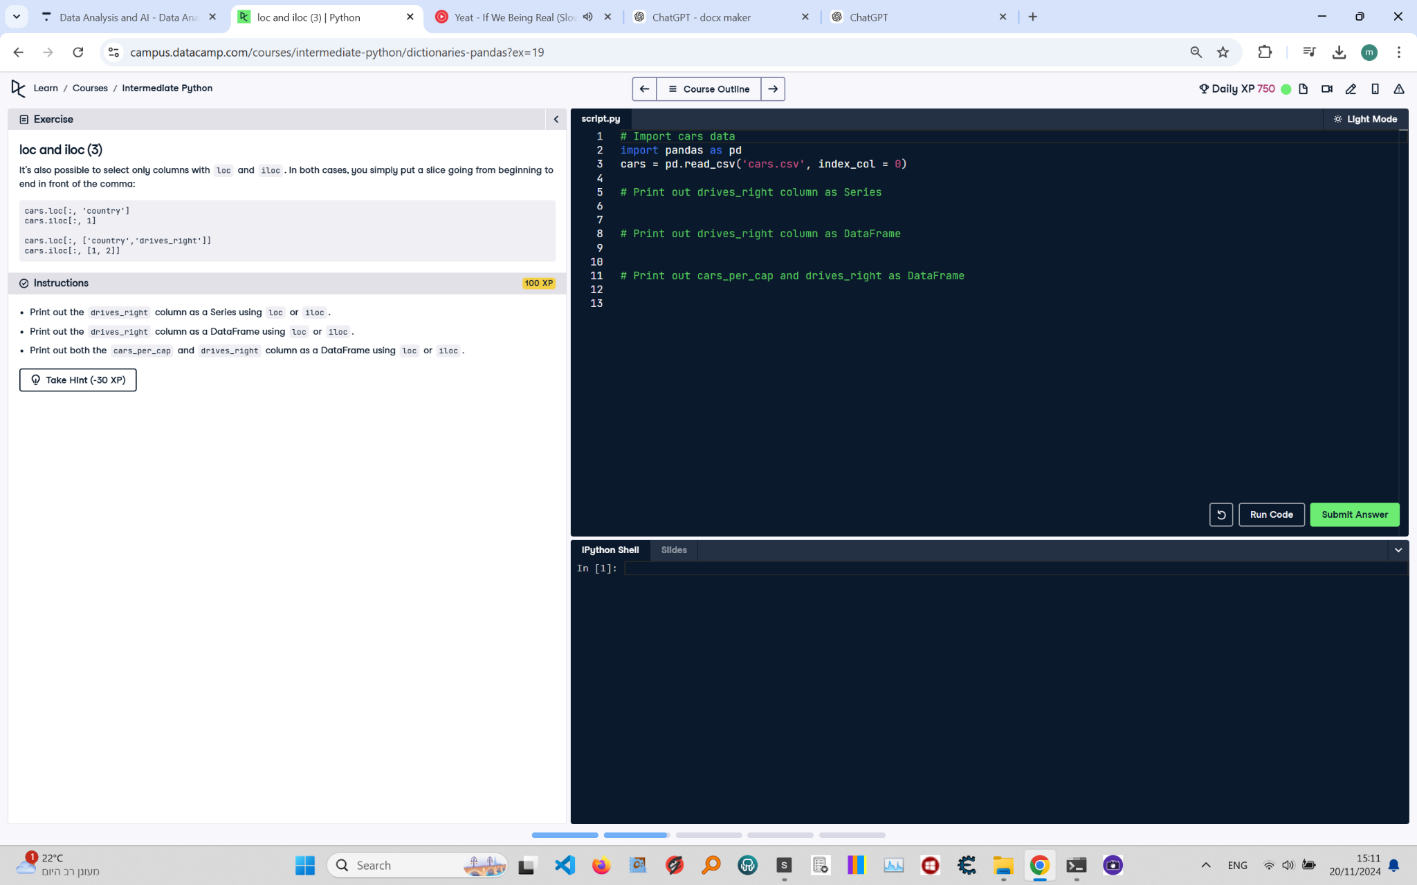

## Question:

1. Print out the drives_right column as a Series using loc or iloc.  
 2. Print out the drives_right column as a DataFrame using loc or iloc.  
 3. Print out both the cars_per_cap and drives_right columns as a DataFrame using loc or iloc.

## Answer:

# Import cars data  
 import pandas as pd  
 cars = pd.read_csv('cars.csv', index_col=0)  
   
 # Print out drives_right column as Series  
 print(cars['drives_right']) # or cars.loc[:, 'drives_right']  
   
 # Print out drives_right column as DataFrame  
 print(cars[['drives_right']]) # or cars.loc[:, ['drives_right']]  
   
 # Print out cars_per_cap and drives_right columns as DataFrame  
 print(cars[['cars_per_cap', 'drives_right']]) # or cars.loc[:, ['cars_per_cap', 'drives_right']]

## Code Explanation:

1. `cars['drives_right']`: Accesses the 'drives_right' column directly as a Series.  
 Alternatively, `cars.loc[:, 'drives_right']` does the same using the loc method, where the colon selects all rows and the column name selects the column.  
 2. `cars[['drives_right']]`: Accesses the 'drives_right' column as a DataFrame.  
 Alternatively, `cars.loc[:, ['drives_right']]` does the same using loc, where the colon selects all rows and the column name in a list selects the column as a DataFrame.  
 3. `cars[['cars_per_cap', 'drives_right']]`: Selects the 'cars_per_cap' and 'drives_right' columns as a DataFrame.  
 Alternatively, `cars.loc[:, ['cars_per_cap', 'drives_right']]` does the same using loc, where the colon selects all rows and the column names in a list select the columns as a DataFrame.